The Dynastic Cycle and the Mandate of Heaven

Read the description and study the chart below, then turn the paper over and read the instructions for your activity.

Mandate of Heaven:

The Chinese believed that heaven gave the leader the mandate, or right, to rule. The people must respect that mandate and owed complete loyalty and obedience to the leader. In exchange for this loyalty, the people had the right to expect good leadership. If there were problems in the dynasty (war, famine, floods, drought) this was a sign that the ruler had lost the Mandate of Heaven. The Mandate of Heaven helped explain the Dynastic cycle which is explained in the diagram below

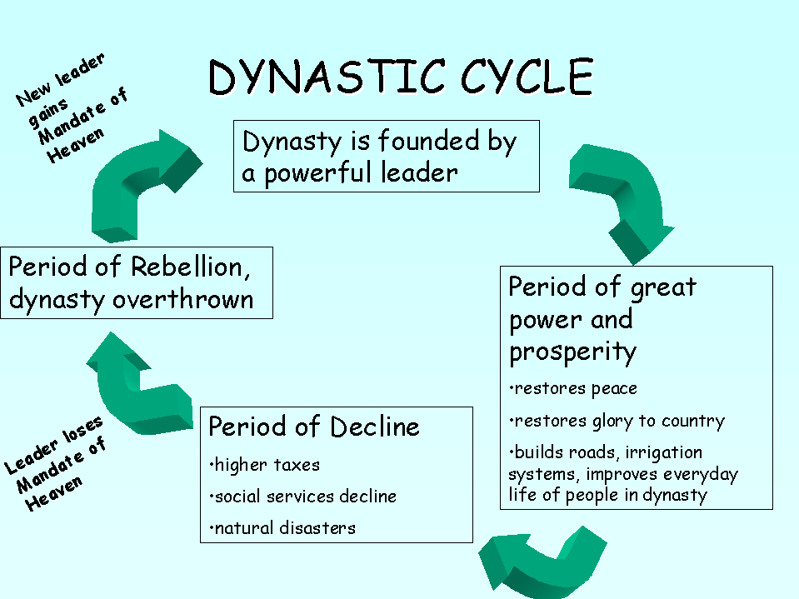

Dynastic Cycle Activity

Think about the dynastic cycle in regard to some other aspect of your life. Would you be able to see the cycle at school? At work? In our government? In technology? In your friendships? Using the paper provided, sketch out and explain your own modern-day dynastic cycle. Pick a modern day context and apply the Dynastic Cycle in a flow diagram like the one shown.

